CHAPTER 2
Data and Sampling Distributions
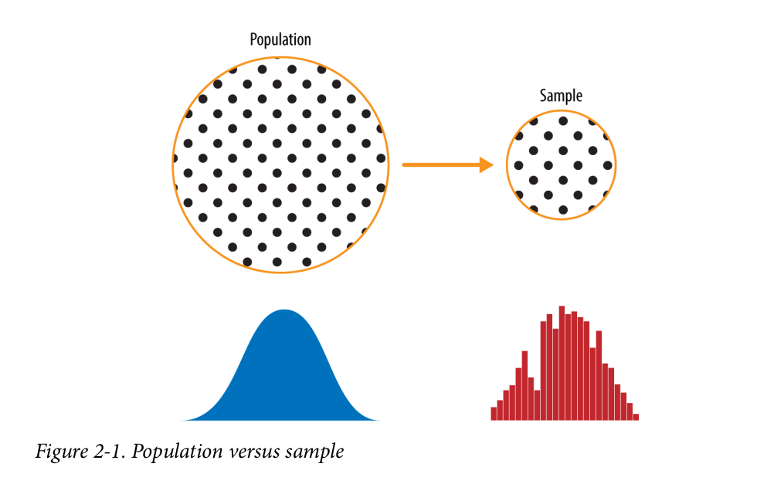

> Random Sampling and Sample Bias
- A sample is a subset of data from a larger data set; statisticians call this larger data set the population.
- Random sampling is a process in which each available member of the population being sampled has an equal chance of being chosen for the sample at each draw. The sample that results is called a simple random sample.
- Sample
A subset from a larger data set.
- Population
The larger data set or idea of a data set.
- N (n)
The size of the population (sample).

- Random sampling
Drawing elements into a sample at random.

- Stratified sampling
Dividing the population into strata and randomly sampling from each strata.

- Stratum (pl., strata)
A homogeneous subgroup of a population with common characteristics.
- Simple random sample
The sample that results from random sampling without stratifying the population.
- Bias
Systematic error. Statistical bias refers to measurement or sampling errors that are systematic and produced by the measurement or sampling process.

- Sample bias
A sample that misrepresents the population.
• Even in the era of big data, random sampling remains an important arrow in the data scientist's quiver.
• Bias occurs when measurements or observations are systematically in error because they are not representative of the full population.
• Data quality is often more important than data quantity, and random sampling can reduce bias and facilitate quality improvement that would otherwise be prohibitively expensive.
> Selection Bias
- Selection bias is the bias introduced by the selection of individuals, groups, or data for analysis in such a way that proper randomization is not achieved, thereby failing to ensure that the sample obtained is representative of the population intended to be analyzed.[1] It is sometimes referred to as the selection effect. The phrase "selection bias" most often refers to the distortion of a statistical analysis, resulting from the method of collecting samples. If the selection bias is not taken into account, then some conclusions of the study may be false.

- Selection bias
Bias resulting from the way in which observations are selected.
- Data snooping
Extensive hunting through data in search of something interesting.
Data snooping occurs when a given set of data is used more than once for purposes of inference or model selection.
split rendomly first then Normalize.
Alternative names: data dredging, data fishing, p-hacking.

- Vast search effect
Bias or nonreproducibility resulting from repeated data modeling, or modeling data with large numbers of predictor variables.
A form of selection bias of particular concern to data scientists is what John Elder (founder of Elder Research, a respected data mining consultancy) calls the vast search effect. If you repeatedly run different models and ask different questions with a large data set, you are bound to find something interesting. But is the result you found truly something interesting, or is it the chance outlier?
> Regression to the Mean
- Regression to the mean refers to a phenomenon involving successive measurements on a given variable: extreme observations tend to be followed by more central ones.
- Regression to the mean is a consequence of a particular form of selection bias.
- Regression to the mean, meaning to “go back,” is distinct from the statistical modeling method of linear regression, in which a linear relationship is estimated between predictor variables and an outcome variable.
> Sampling Distribution of a Statistic
- Sample statistic
A metric calculated for a sample of data drawn from a larger population.

- Data distribution
The frequency distribution of individual values in a data set.

- Sampling distribution
The frequency distribution of a sample statistic over many samples or resamples.

- Central limit theorem
The tendency of the sampling distribution to take on a normal shape as sample size rises.

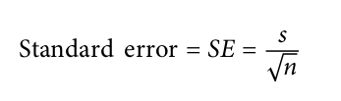
- Standard error
The variability (standard deviation) of a sample statistic over many samples (not to be confused with standard deviation, which by itself, refers to variability of individual data values).

• It is important to distinguish between the distribution of the individual data points, known as the data distribution, and the distribution of a sample statistic, known as the sampling distribution.
• The distribution of a sample statistic such as the mean is likely to be more regular and bell-shaped than the distribution of the data itself. The larger the sample the statistic
is based on, the more this is true. Also, the larger the sample, the narrower the distribution of the sample statistic.
> Central Limit Theorem
- In probability theory, the central limit theorem (CLT) states that the distribution of a sample variable approximates a normal distribution (i.e., a “bell curve”) as the sample size becomes larger, assuming that all samples are identical in size, and regardless of the population's actual distribution shape.
> Standard Error
(maybe - the standard deviation of the sampling distribution of the sample mean)
- It is called an error because the standard deviation of the sampling distribution tells us how different a sample mean can be expected to be from the true mean.
- The relationship between standard error and sample size is sometimes referred to as the square root of n rule: to reduce the standard error by a factor of 2, the sample size must be increased by a factor of 4.
> Link
- https://onlinestatbook.com/stat_sim/sampling_dist/
- https://www.khanacademy.org/math/ap-statistics/sampling-distribution-ap/sampling-distribution mean/v/standard-error-of-the-mean
> The Bootstrap
The bootstrap can be used for sample size determination; experiment with different values for n to see how the sampling distribution is affected.
- https://www.statisticshowto.com/bootstrap-sample/

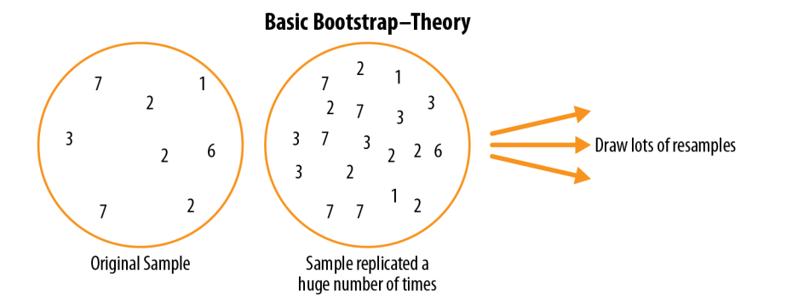

- Bootstrap sample
A sample taken with replacement from an observed data set.\
- Resampling
The process of taking repeated samples from observed data; includes both bootstrap and permutation (shuffling) procedures.
- bagging (short for “bootstrap aggregating”)
https://en.wikipedia.org/wiki/Bootstrap_aggregating
- Resampling Versus Bootstrapping
- multiple samples are combined and the sampling may be done without replacement.
- the term bootstrap always implies sampling with replacement from an observed data set.
- Confidence Intervals
The percentage of confidence intervals, constructed in the same way from the same population, that are expected to contain the statistic of interest.
- For a data scientist, a confidence interval is a tool that can be used to get an idea of how variable a sample result might be. Data scientists would use this information not to publish a scholarly paper or
submit a result to a regulatory agency (as a researcher might) but most likely to communicate the potential error in an estimate, and perhaps to learn whether a larger sample is needed.
- https://www.youtube.com/watch?v=tFWsuO9f74o
- Interval endpoints
The top and bottom of the confidence interval.

> Normal Distribution
- The bell-shaped normal distribution is iconic in traditional statistics.
- The normal distribution is also referred to as a Gaussian distribution after Carl Friedrich Gauss, a prodigious German mathematician from the late 18th and early 19th centuries. Another name previously used for the normal distribution was the “error” distribution. Statistically speaking, an error is the difference between an actual value and a statistical estimate like the sample mean.

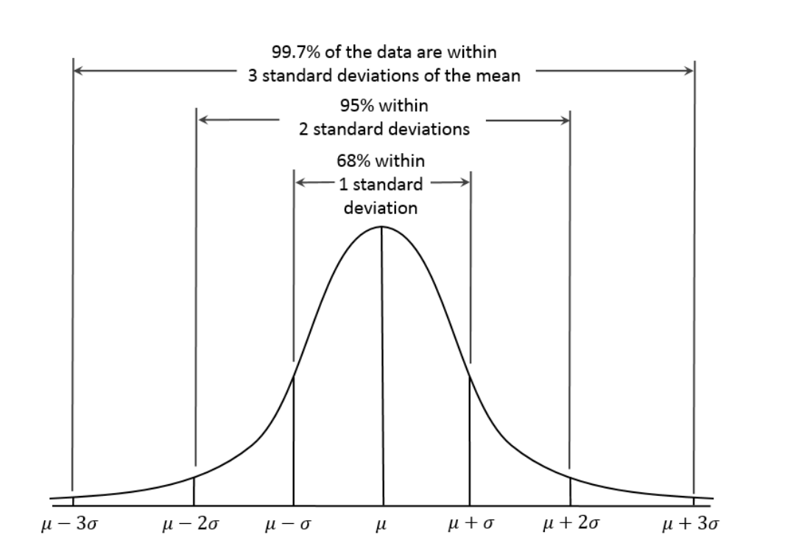
For example, the standard deviation is based on the errors from the mean of the data. Gauss’s development of the normal distribution came from his study of the errors of astronomical measurements that were found to be normally distributed.

- Error
The difference between a data point and a predicted or average value.
- Standardize
Subtract the mean and divide by the standard deviation.
- z-score
The result of standardizing an individual data point.
- Standard normal
A normal distribution with mean = 0 and standard deviation = 1.
- QQ-Plot
A plot to visualize how close a sample distribution is to a specified distribution, e.g., the normal distribution.
> Standard Normal and QQ-Plots
A standard normal distribution is one in which the units on the x-axis are expressed in terms of standard deviations away from the mean. To compare data to a standard normal distribution, you subtract the mean and then divide by the standard deviation; this is also called normalization or standardization

Note that “standardization” in this sense is unrelated to database record standardization (conversion to a common format). The transformed value is termed a z-score, and the normal distribution is sometimes called the z-distribution.
> Long-Tailed Distributions
- Tail
The long narrow portion of a frequency distribution, where relatively extreme values occur at low frequency.
- Skew
Where one tail of a distribution is longer than the other.
Link - https://onlinestatbook.com/2/estimation/t_distribution.html
> Student’s t-Distribution (also called T distribution)
The t-distribution is actually a family of distributions resembling the normal distribution but with thicker tails.
- https://www.statisticshowto.com/probability-and-statistics/t-distribution/
- Degrees of freedom
A parameter that allows the t-distribution to adjust to different sample sizes, statistics, and numbers of groups.

> Binomial Distribution
The binomial distribution is the frequency distribution of the number of successes (x) in a given number of trials (n) with specified probability (p) of success in each trial.
- https://www.mathsisfun.com/data/binomial-distribution.html
- https://www.youtube.com/watch?v=gT26Y_VJmOM
- Trial
An event with a discrete outcome (e.g., a coin flip).
- Success
The outcome of interest for a trial.
Synonym - “1” (as opposed to “0”)
- Binomial
Having two outcomes.
Synonyms - yes/no, 0/1, binary
- Binomial trial
A trial with two outcomes.
Synonym - Bernoulli trial
- Binomial distribution
Distribution of number of successes in x trials.
Synonym - Bernoulli distribution
> Chi-Square Distribution
It is the difference between the observed and expected values, divided by the square root of the expected value, squared, then summed across all categories.
A low chi-square value for a set of counts indicates that they closely follow the expected distribution. A high chi-square indicates that they differ markedly from what is expected. There are a variety of chi-square distributions associated with different degrees of freedom (e.g., number of observations
- https://www.youtube.com/watch?v=2pKQhCntI6Q
> F-Distribution
- The F-distribution is used with experiments and linear models involving measured data.
- The F-statistic compares variation due to factors of interest to overall variation.
> Poisson and Related Distributions
- Lambda
The rate (per unit of time or space) at which events occur.
- Poisson distribution
The frequency distribution of the number of events in sampled units of time or space.

- Exponential distribution
The frequency distribution of the time or distance from one event to the next event.

- Weibull distribution
A generalized version of the exponential distribution in which the event rate is allowed to shift over time. Weibull distribution is an extension of the exponential distribution in which the event rate is allowed to change, as specified by a shape parameter, β . If β > 1, the probability of an event increases over time; if β < 1, the probability decreases. Because the Weibull distribution is used with time-to-failure analysis instead of event rate, the second parameter is expressed in terms of characteristic life, rather than in terms of the rate of events per interval. The symbol used is η , the Greek letter eta. It is also called the scale parameter.

